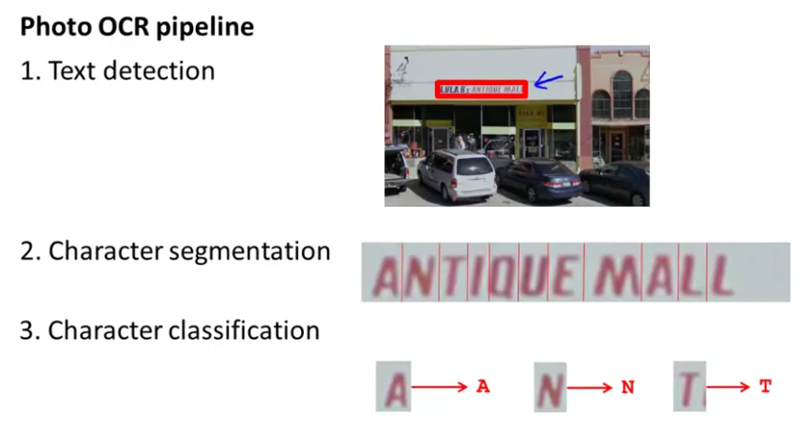

**Sliding windows**

When working with image processing, you usually choose a sliding window of a determined dimension and you slide it over the whole image in a chosen step size.

**Artificial Data Synthesis**

We can obtain more data for aour training set by generating data from scratch using random as well by taking an existing example and introducing distortions that enlarge the training set.

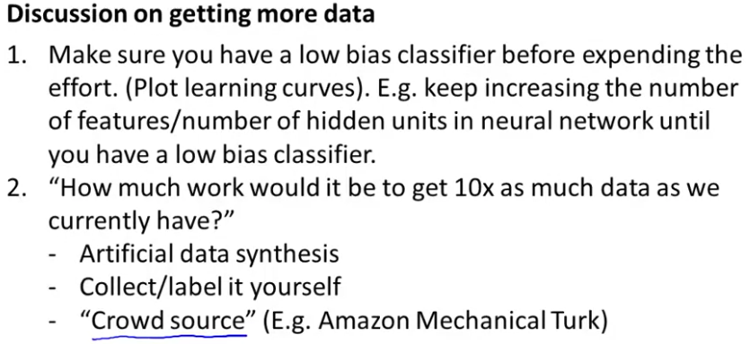

**Ceiling analysis**

In order to know in which step its more worth it to spend more time in improving, what you can do is calculate the performance of the overall system and then see how much it improves if each step worked perfectly. This way, we can see the influence each step has in the overall performance, and so you can choose where to work.

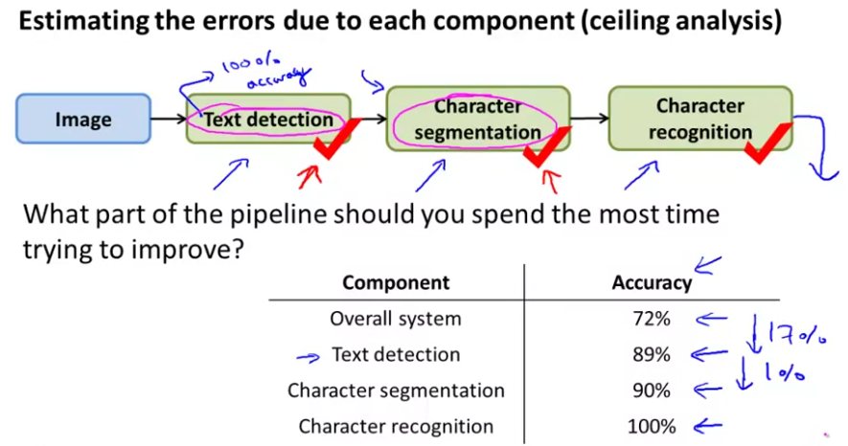

In this example, we can see that the step that improves more the overall performance is the text detection algorithm, so we should focus in improving this step.